011 Gulp - optimizing javascript

Gulp Kata List – Blog Page

[Gulp Kata List on GitHub](https://github.com/robertdunaway/katas-gulp)

# Duration

5 minutes

# Brief

Optimize all JavaScript files in the wwwroot folder.

### For More Information

BING/GOOGLE: “Gulp minify javascript”

Book: <http://www.amazon.com/Gulp-Quick-guide-getting-running/dp/151468960X>

# Instructions

Get tutorial folder or the entire katas-angular2 repo.

Open the [before/*.sln] file and execute the kata.

Feel free to execute this kata multiple times because repetition creates motor memory.

# Github

* Before (start kata with this)
  + https://github.com/robertdunaway/katas-gulp/tree/master/011%20Gulp%20-%20optimizing%20javascript/before
* After
  + https://github.com/robertdunaway/katas-gulp/tree/master/011%20Gulp%20-%20optimizing%20javascript/after

# Kata

After all files are copied to wwwroot, minify all the JavaScript files but do not minify any “*.min.js” files. IE: Don’t minify JavaScript files that have already been minified.

Install the gulp-uglify plugin.

npm install gulp-uglify --save-dev

npm install gulp-rename --save-dev

npm install gulp-sourcemaps --save-dev

Add a reference to plugins.

var gulp = require('gulp')

, uglify = require('gulp-uglify')

, rename = require('gulp-rename')

, sourcemaps = require('gulp-sourcemaps');

Create tasks

Copy all files to the wwwroot folder.

gulp.task('copy-to-wwwroot', function () {

return gulp.src(['src/**/*'])

.pipe(gulp.dest('wwwroot'));

});

Minify all non-minified JavaScript files in wwwroot.

gulp.task('minify-js', function () {

return gulp.src(['wwwroot/**/!(*.min).js', '!wwwroot/lib/**/*'])

.pipe(sourcemaps.init())

.pipe(uglify())

.pipe(rename({

extname: '.min.js'

}))

.pipe(sourcemaps.write('./'))

.pipe(gulp.dest('wwwroot/./'));

});

Step through minify-js

1 Selecting all JavaScript files except already minified files.

2 Begin the sourcemaps process.

3 Perform the JavaScript optimization with uglify().

4 Rename the new file. This way we’ll have the original file, a minified version of the file, and a map file.

5 Write out the source map file.

6 Set the destination which is wwwroot.

You’ll notice only *.js files were minified but existing *.min.js files were left alone.

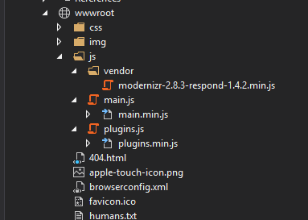

# Next

Take a few minutes and imagine more examples.